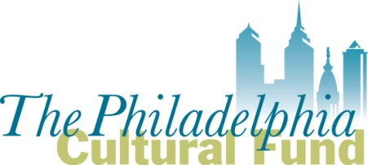
2017 Fiscal Sponsor Application

For nonprofit organizations requesting to serve as a fiscal sponsor for groups applying for Philadelphia Cultural Fund grants. Submit completed application and attachments to Michelle Currica, Program Manager, at michelle@philacutluralfund.org

DEADLINE, Friday September 2, 2016 at 5:00 pm

- Name of organization:

- Organization’s mission:

- Has your organization served as a fiscal sponsor before? _____Yes _______No

- If yes, when did your organization serve as a fiscal sponsor? (dates/years)

- If yes, provide the name/s of the groups/projects for which you have served as a fiscal sponsor; provide their area of focus (ex: arts group, community project, etc.)

- If yes, what is your administrative fee? Provide the specific percentages and/or fee amounts below.

- Are there groups or projects for which you are currently interested in serving as fiscal sponsor in their application for a Philadelphia Cultural Fund grant? If so, list below.

- Briefly describe why your organization wants to serve as a fiscal sponsor for groups applying to the Philadelphia Cultural Fund.

- Does your organization produce its own artistic or cultural programming?
___ Yes ___ No.
If yes, briefly describe the programs.

- List your personnel who are (or will be) responsible for managing your fiscal sponsorship contracts. Provide the name, title/role, if they are full time or part-time and if they are staff or volunteer.

- Which Fiscal Sponsor model best describes your sponsor/project relationships? See Fiscal Sponsor Guidelines for further details.

  - Charitable Program Model ____
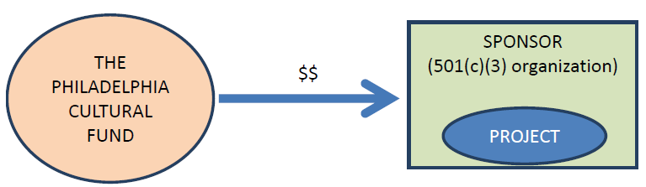

  - Re-Granting Model ____
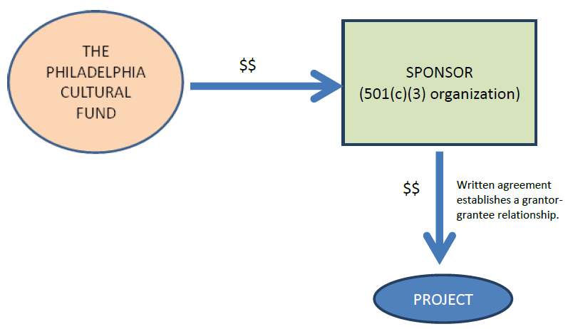

  - Independent Contractor Model ____

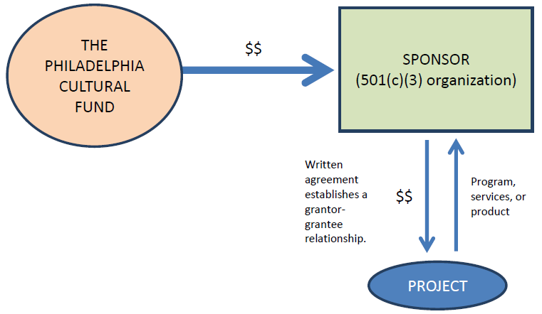

- What services do you, or will you, provide to sponsored groups/projects?

Attach the following with your submission:
- Your organization’s IRS letter of 501(c)(3) determination
- A sample of the fiscal sponsor agreement your organization has used for its sponsored groups/projects.

