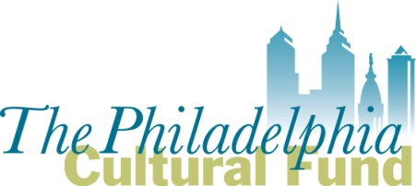

2017 Peer Panelist Application
Submit completed form to Michelle Currica, Program Manager, at michelle@philaculturalfund.org

DEADLINE, Friday September 30, 2016 at 5pm
- Name

- Do you now, or have you in the past, been employed by a non-profit arts and culture organization?
  - Yes
    - Which non-profit(s)?
    - In what role(s)?
  - No

- Do you now, or have you in the past, served as a volunteer or board member for a non-profit arts and culture organization?
  - Yes
    - Which non-profit(s)?
    - In what role(s)?
  - No

- What best describes your qualifications to serve as a peer panelist? (you may select more than one)
  - An artist
  - An arts administrator
  - An arts advocate
  - An arts educator
  - Other ____________________

- How do you self identify…
  - Racially/Ethnically?
  - Which gender pronouns do you use?
    - She/Her
    - He/Him
    - They/Them
    - Another gender pronoun not provided above: _________________
  - What is your age range?
    - 18-25
    - 26-35
    - 36-54
    - 46-55
    - 56-65
    - 66+

- Artistic discipline of experience (you may select more than one)
  - Arts Education
  - Arts Service
  - Community Art
  - Dance
  - Historic Site
  - Literary
  - Museum
  - Music
  - Presenter/Multi-Disciplinary
  - Theatre
  - Visual Arts/Media
  - Other, please describe briefly

- What is the approximate size of the organization(s) you have been affiliated with? Please choose the closest match:
  - Less than $50,000 (mostly volunteer staff)
  - $50,000 to $150,000 (volunteer or some paid staff)
  - $150,000 to $400,000 (mix of part-time and volunteer staff)
  - $400,000 to $1.5 million (paid staff and distinct roles)
  - $1.5 million and over (paid staff, distinct roles, dedicated departments)

- Do you have dietary restrictions?

- Do you have schedule limitations for the month of December?

- Do you speak a foreign language? What is your level of proficiency?

- Please provide your preferred email address. This will be the main point of contact from the Cultural Fund.

- Please provide your cell phone number. The Cultural Fund will only use this to contact you the event of an emergency.

- Please attach your most current resume with your email.

The Philadelphia Cultural Fund is a non-profit corporation established by Philadelphia’s Mayor and City Council in 1991 to support and enhance the cultural life and vitality of the City of Philadelphia and its residents. The Fund promotes art and culture as engines of social, educational and economic development in the Philadelphia region. Grants are made from the City budget allocation to the Cultural Fund for operating support of Philadelphia-based arts and cultural organizations.

