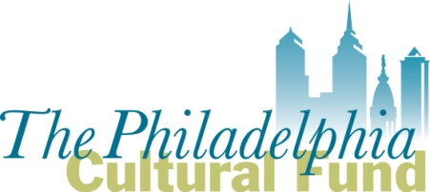

Fiscal Sponsor Application

For 501(c) (3) nonprofit organizations requesting to serve as a fiscal sponsor for Philadelphia based groups applying for a Philadelphia Cultural Fund grant.

Submit completed application and attachments to Michelle Currica, Program Manager, at michelle@philaculturalfund.org

DEADLINE for 2018 Art & Culture Grant eligibility is
Friday September 1, 2017 at 5:00 pm

- Name of organization applying to serve as a Fiscal Sponsor:

- Mission of nonprofit applicant:

- Has the organization served as a fiscal sponsor before? _____Yes _______No

- If yes, when did the organization serve as a fiscal sponsor? (dates/years)

- If yes, provide the name(s) of the groups/projects for which it served as a fiscal sponsor; provide their area of focus (ex: arts group, community project, etc.).

- If yes, what is the administrative fee to the groups or projects it will sponsor? Provide the specific percentages and/or fee amounts.

- Are there groups or projects the organization is interested in serving as fiscal sponsor for a Philadelphia Cultural Fund grant? If so, list below. Please include their city of operation.

- Briefly describe why the organization wants to serve as a fiscal sponsor for groups applying to the Philadelphia Cultural Fund.

- Does the organization produce its own artistic or cultural programming?
___ Yes ___ No.
If yes, briefly describe the programming.

- List the personnel who are (or will be) responsible for managing fiscal sponsorship contracts. Provide the name, title/role, if they are full time or part-time and if they are staff or volunteer.
- Which Fiscal Sponsor model best describes your organization’s sponsor/project relationships? See Fiscal Sponsor Guidelines for further details.

  - Charitable Program Model ____
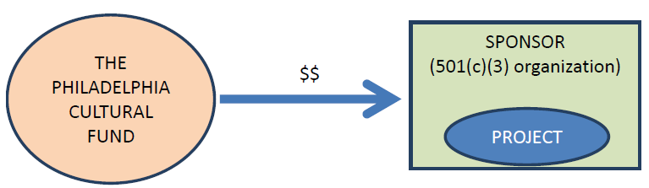

  - Re-Granting Model ____
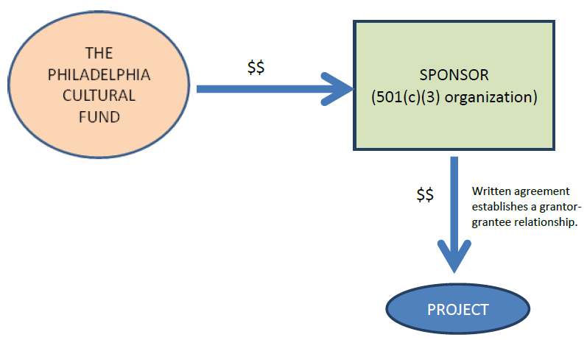

  - Independent Contractor Model ____

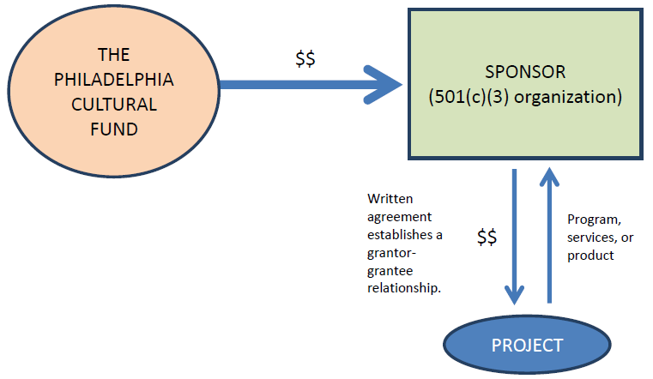

- What services does, or will, your organization provide to sponsored groups/projects?

Attach the following with your submission:
- The organization’s IRS letter of 501(c)(3) determination
- A sample fiscal sponsor agreement your organization has used for its sponsored groups/projects if applicable.

