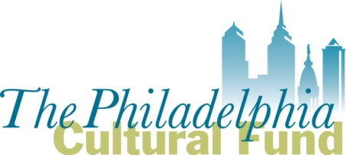

Fiscal Sponsor Application

This application is for 501(c) (3) nonprofit organizations requesting to serve as a fiscal sponsor for Philadelphia based groups applying for a Philadelphia Cultural Fund (PCF) grant.

Submit completed application and attachments to Michelle Currica, Program Manager, at michelle@philaculturalfund.org

You may call 267-419-7641 if you have questions

DEADLINE to submit Application for consideration of 2019 Art & Culture Grant eligibility is
Friday September 7, 2018 at 5:00 pm

- Name of 501 (c) (3) organization applying to serve as a Fiscal Sponsor:

- Mission of the applicant:

- Has the organization served as a PCF fiscal sponsor for before? _____Yes _______No

3-a) If yes, when? (dates/years)

3-b) If yes, provide the name(s) of the groups/projects for which it served as a fiscal sponsor; provide their area of focus (ex: arts group, community project, etc.).

3-c) If yes, what administrative fee is charged to the groups or projects it sponsors? Provide the specific percentages and/or fee amounts.

3-d) If no, what specific percentages and/or fees does the applicant intend to charge potential groups/projects?

- Are there groups or projects the applicant knows now that it is interested in sponsoring for a PCF grant? If so, list below. Please include their address.

- Briefly describe why the applicant wants to serve as a fiscal sponsor for groups applying to the Philadelphia Cultural Fund.

- Does the applicant produce its own artistic or cultural programming?
___ Yes ___ No.
If yes, briefly describe the programming.
- List the personnel who are (or will be) responsible for managing fiscal sponsorship contracts. Provide the name, title/role, if they are full time or part-time and if they are staff or volunteer.

- Which Fiscal Sponsor model best describes the applicant’s sponsor/project relationships? See Fiscal Sponsor Guidelines for further details.

  - Charitable Program Model ____
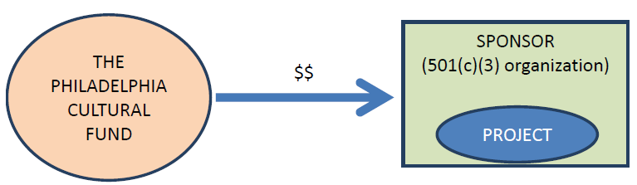

  - Re-Granting Model ____
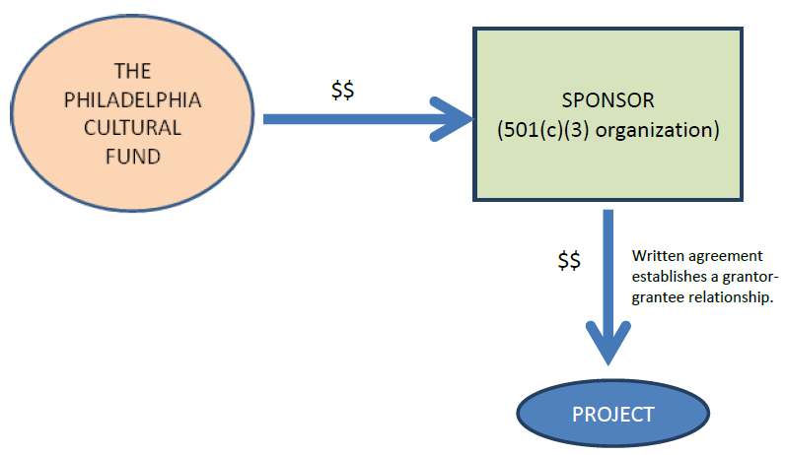

  - Independent Contractor Model ____

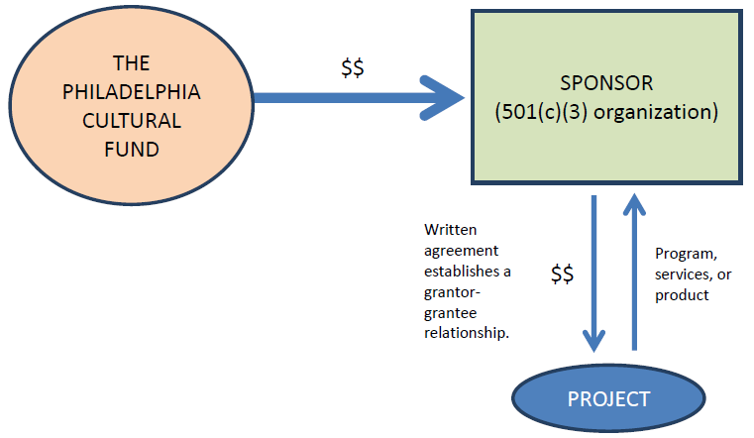

- What services does, or will, the applicant provide to sponsored groups/projects?

Attach the following with this application so it can be considered:
- The applicant’s IRS letter of 501(c)(3) determination
- The applicant’s most recently filed, board approved Form 990
- A sample fiscal sponsor agreement the applicant may use for its sponsored groups/projects, if approved.

Note: All grant applications submitted by groups using a fiscal sponsor must attach a copy of their current and fully executed fiscal sponsor agreement. These are reviewed by PCF during pre-screening to qualify grant applicants. Applications with incomplete, inaccurate or inappropriate fiscal sponsor agreements could be disqualified. The Philadelphia Cultural Fund can share, upon request, a sample Fiscal Sponsor Agreement.

