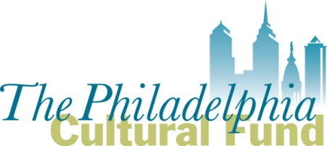

Fiscal Sponsor/Parent Organization Application

This application must be completed by any 501(c) (3) nonprofit organization requesting to serve as a fiscal sponsor/parent organization for Philadelphia based groups applying for a Philadelphia Cultural Fund (PCF) grant.

Submit completed application and attachments to Michelle Currica, Program Manager, at michelle@philaculturalfund.org

Call 267-419-7641 if you have questions

Application DEADLINE to serve as fiscal sponsor/parent organization for the 2020 Art & Culture Grant cycle is
Friday September 6, 2019 at 5:00 pm

- Name of 501 (c) (3) organization applying to serve as a Fiscal Sponsor/Parent Organization:

- Mission of the applicant Fiscal Sponsor/Parent Organization:

- Has the applicant served as fiscal sponsor/parent organization for a Philadelphia Cultural Fund (PCF) applicant or grantee before? _____Yes _______No

3-a) If yes, when? (dates/years)

3-b) If yes, provide the name(s) of the groups/projects for which it served as fiscal sponsor/parent organization; provide the group’s area of focus (ex: arts group, community project, etc.).

3-c) If yes, what administrative fee was charged to the groups or projects it sponsored? Provide the specific percentages and/or fee amounts.

3-d) If no, what specific percentages and/or fees does the applicant intend to charge potential groups/projects?

- Are there groups or projects the applicant knows now that it is interested in sponsoring for a PCF grant? If so, list below and include their address.

- Briefly describe why the applicant wants to serve as a sponsor for groups applying to the Philadelphia Cultural Fund.

- Does the applicant produce its own artistic or cultural programming?
___ Yes ___ No.
If yes, briefly describe the programming.

- List the personnel who are (or will be) responsible for managing fiscal sponsorship/parent organization contracts. Provide the name, title/role, if they are full time or part-time and if they are staff or volunteer.

- Which Sponsorship model best describes the applicant’s sponsor relationship to the program or groups that will apply for a Philadelphia Cultural Fund grant? See Fiscal Sponsor Guidelines for further details.

  - Charitable Program Model ____
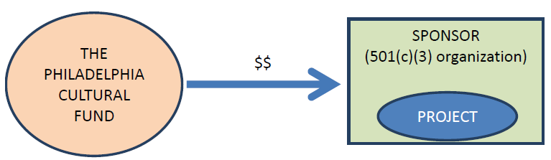

  - Re-Granting Model ____
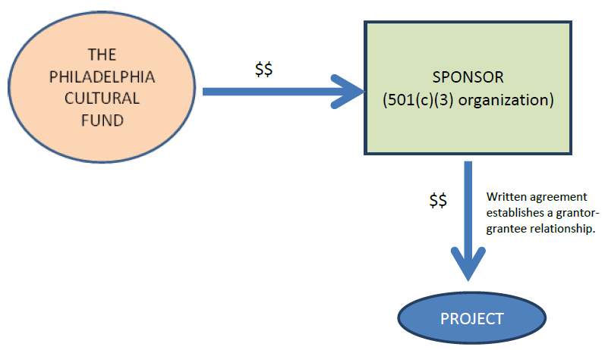

  - Independent Contractor Model ____

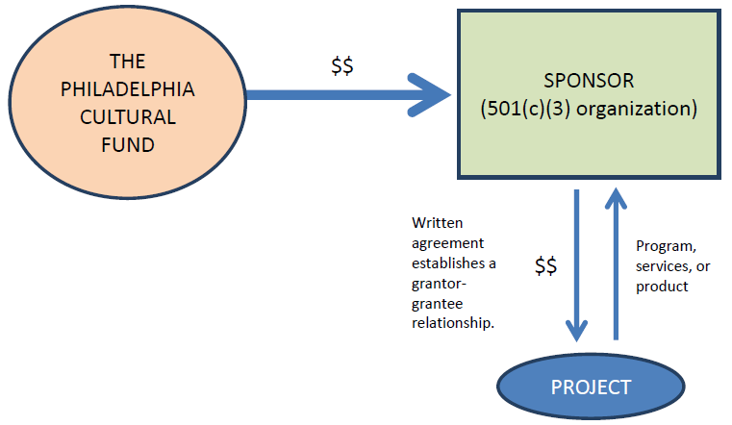

- What services will the applicant provide to sponsored groups/programs? Be thorough.

The following must be attached with this application to be considered:
- The applicant’s IRS letter of 501(c)(3) determination
- The applicant’s most recently filed, board approved Form 990
- A sample fiscal sponsor/parent organization agreement the applicant may use for its sponsored groups/programs, if approved.

Note: All grant applications submitted by groups using a fiscal sponsor/parent organization must attach a copy of their current and fully executed fiscal sponsor/parent organization agreement. These are reviewed by PCF staff during pre-screening to qualify grant applicants. Grant applications with incomplete, inaccurate or inappropriate fiscal sponsor/parent organization agreements could be disqualified. The Philadelphia Cultural Fund can share, upon request, a sample Fiscal Sponsor Agreement.

